Data Analytics Final Exams
Alieu Samateh | Student ID 3793730

Q1 - Part A: Selecting Clustering Algorithms
From the provided list, we select the following three complementary algorithms:
- K-Means Clustering (K-Means)
- Gaussian Mixture Model (GMM)
- DBSCAN
These algorithms are chosen because they represent different clustering philosophies:
- K-Means (centroid-based): K-Means clusters data by assigning points to the nearest centroid, aiming to minimize within-cluster variance.
- GMM (probabilistic/model-based): Gaussian Mixture Models assume data is generated from a mixture of Gaussian distributions and assign points to clusters based on probability estimates.
- DBSCAN (density-based): DBSCAN identifies clusters as dense regions of points separated by areas of lower density, allowing it to detect arbitrarily shaped clusters and noise.

Selected Algorithm Training
- true_label is not used during clustering/training
- K-Means and GMM require specifying the number of clusters/components, in this case I used 3.
- DBSCAN automatically determines the number of clusters based on density.
- DBSCAN may assign some points as noise, which is expected behavior.
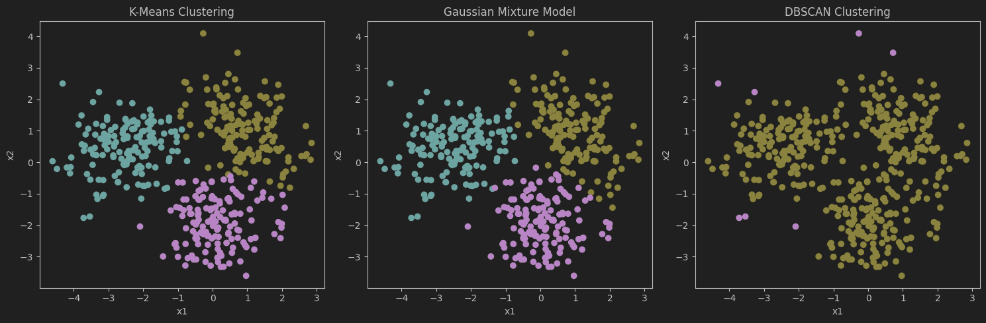

Q1 - Part B: Hyperparameter Identification and Tuning
For each selected clustering algorithm that is, K-Means, GMM, DBSCAN, key hyperparameters are identified and tuned using quantitative validation metrics and visual inspection, since clustering is an unsupervised task.

K-Means Hyperparameter Tuning

Key Hyperparameters Identified
- Number of clusters (k)
- Initialization method (init)

Method
The Elbow Method and Silhouette Score were used to evaluate values of k from 2 to 6, with the Elbow plot showing a clear point of diminishing returns and the Silhouette Score peaking at the same value. The k-means++ initialization was used to reduce sensitivity to initial centroid placement, improving convergence stability and clustering reliability.

Best Configuration
- k = 3
- init = k-means++
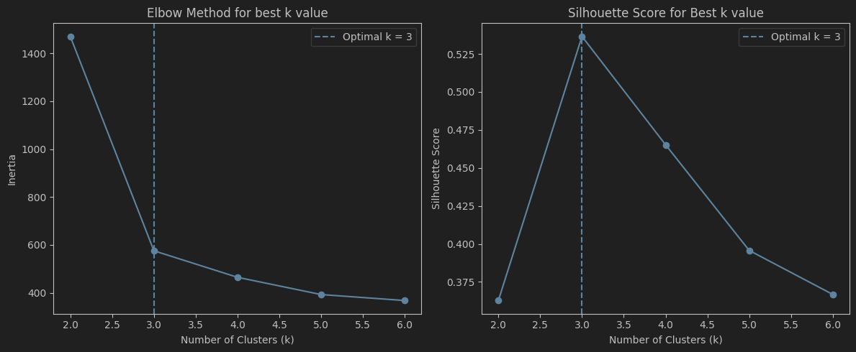
The silhouette scores peak at k=3, indicating that three clusters provide the best separation and cohesion for the dataset.

Justification
The optimal number of clusters was selected by jointly analyzing the Elbow Method and Silhouette Score, both of which indicate k=3k = 3k=3 as the most appropriate choice.

Gaussian Mixture Model (GMM) Hyperparameter Tuning

Key Hyperparameters Identified
- Number of components (n_compnents)
- Covariance type (full, tied, diag, spherical)

Method
- Models were evaluated using Bayesian Information Criterion (BIC), which balances model fit and complexity.
- Multiple covariance structures were tested for 2–6 components.

Best Configuration
- n_components = 3
- covariance_type = 'full'
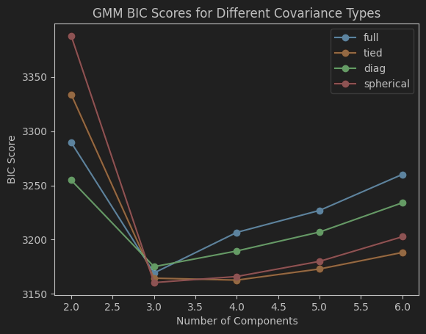
BIC was used to compare GMM models with varying numbers of components and covariance structures. The model with three components and full covariance achieved the lowest BIC score, indicating it best captures the underlying data distribution without overfitting.

Justification
The lowest BIC score was achieved with 3 components and full covariance. Full covariance allows clusters to take elliptical shapes, which better models the underlying data distribution.

DBSCAN Hyperparameter Tuning

Key Hyperparameters Identified
- ε (epsilon) – neighborhood radius
- min_samples – minimum points to form a dense region

Method
A k-distance plot, with k=min_samples, was used to estimate an appropriate value for the epsilon (ε) parameter by identifying the point of maximum curvature. Multiple ε values were then tested and evaluated using the Silhouette Score, excluding noise points, alongside visual inspection of the resulting cluster structures. This combined approach ensured a balance between meaningful cluster formation and minimal noise.

Best Configuration
- eps = 0.5
- min_samples = 5
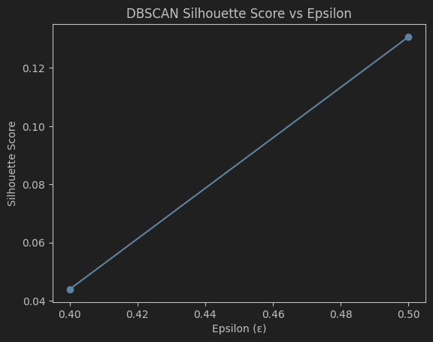

Justification

The silhouette score increases as ε grows from 0.4 to 0.5, indicating that a larger neighborhood radius improves cluster cohesion and separation by reducing fragmentation. At ε = 0.5, DBSCAN captures the better underlying dense regions while limiting excessive noise, resulting in improved clustering quality. This suggests that ε = 0.5 is a more suitable parameter choice for this dataset.
The value min_samples = 5 was selected as it satisfies the dimensionality-based rule of thumb and yields stable clusters while effectively filtering out noise without excessive fragmentation.

Q1- Part C: Algorithm Evaluation and Comparison
Evaluating and Comparing the Algorithms on clustering metrics (Silhouette Score, Davies–Bouldin Index, Calinski–Harabasz Index)

Comparison Table
The Comparison table show that K-Means performed best followed closely by GMM. Higher is better for Silhouette and Calinski–Harabasz, while lower is better for Davies–Bouldin.
Algorithm | Silhouette Score | Davies–Bouldin Index | Calinski–Harabasz Index
K-Means | 0.5365 | 0.6306 | 660.9715
GMM | 0.5337 | 0.6347 | 647.7046
DBSCAN | N/A | N/A | N/A
DBSCAN is N/A?
DBSCAN assigned a large portion of points as noise or formed fewer than two valid clusters after noise removal, making these metrics undefined.

Algorithm Ranking from best to worst
- K-Means
- GMM
- DBSCAN

Justification
- K-Means achieved the highest Silhouette Score and Calinski–Harabasz Index, and the lowest Davies–Bouldin Index.
- GMM performed very similarly but slightly below K-Means across all metrics.
- DBSCAN could not be reliably evaluated using these metrics due to excessive noise or insufficient cluster formation.

Interpretation and Metric Disagreement
K-Means gained better performance on both Silhouette Score and Calinski–Harabasz Index, reflecting strong cluster cohesion and separation. The Davies–Bouldin Index also supports this ranking by assigning K-Means the lowest value, indicating minimal cluster overlap. DBSCAN’s inability to produce valid metric values highlights a limitation of density-based methods on datasets with relatively uniform cluster densities, where internal metrics may fail due to noise handling.

Q1- Part D: Plot Clustered Data and Decision Boundary

Plot the clustered data for each algorithm
Clustered data points are visualized for each algorithm using scatter plots, with colors indicating cluster assignments.
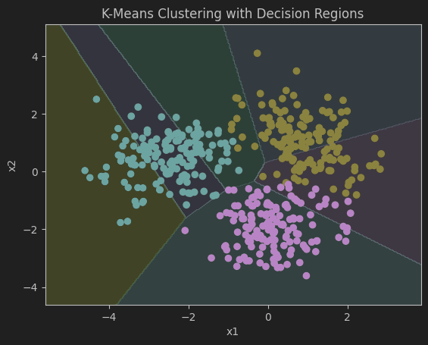 | 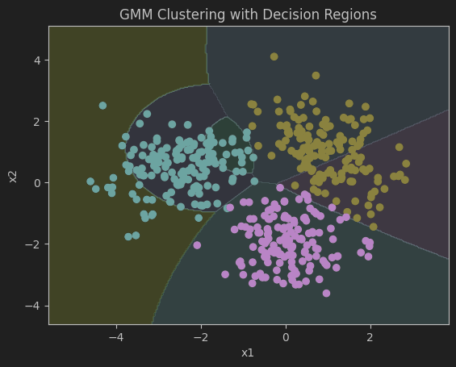 | 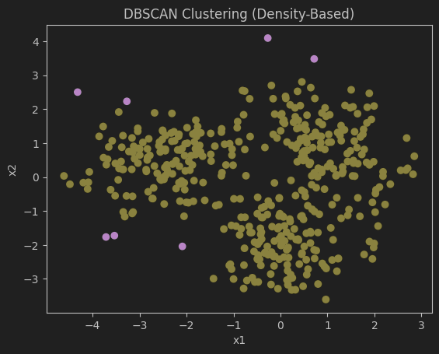
K-Means clustering results with decision regions illustrating Voronoi partitions based on Euclidean distance. | Gaussian Mixture Model (GMM) clustering results with probabilistic decision regions reflecting elliptical cluster shapes and covariance structure | DBSCAN clustering results showing density-based cluster formation, with dense regions identified as clusters and sparse points treated as noise, without explicit decision boundaries.

Overlay decision boundaries or cluster regions where applicable
Decision regions are overlaid for K-Means and GMM to show how the feature space is partitioned, while DBSCAN is shown without boundaries due to its density-based clustering mechanism.

Commentary on Clustering Behavior

Cluster Shape and Separation
K-Means creates tight, well-separated clusters with clear straight-line boundaries, showing strong separation in the feature space. GMM produces smoother, more flexible clusters that can stretch and overlap, allowing it to better capture variations in the data. In contrast, DBSCAN groups points based on density, which leads to clusters with irregular shapes rather than clearly defined boundaries.

Misclustered or Ambiguous Regions
K-Means can sometimes assign points near cluster boundaries to the wrong group because it relies on strict distance-based decisions. GMM deals with these ambiguous areas more gracefully by using probabilities, which softens hard assignments and reduces misclassification. DBSCAN takes a different approach by treating low-density or boundary points as noise instead of forcing them into a cluster, which helps avoid incorrect assignments but may leave out some valid points.

Differences in Space Partitioning
K-Means divides the entire feature space into clear regions and assigns every point to a cluster. GMM takes a softer approach by partitioning the space probabilistically, which allows clusters to overlap and creates smoother transitions between them. DBSCAN, on the other hand, does not divide the whole space at all; it focuses only on dense areas and leaves sparse regions unassigned.

Q1- Part E: Algorithm That Best Matches the True Data-Generating Process
K-Means best matches the true data-generating process for this dataset. The synthetic data consists of three well-separated, compact clusters that are approximately spherical, which aligns closely with K-Means’ assumption of equal-variance, distance-based clusters. This is supported by its superior performance across evaluation metrics, including the highest Silhouette and Calinski–Harabasz scores and the lowest Davies–Bouldin index. The clear linear decision boundaries and minimal cluster overlap observed in the plots further confirm that K-Means captures the underlying structure of the data most effectively.

Part E (2): Effect of Changes in Data Characteristics

If the number of clusters were unknown
Algorithms such as K-Means and GMM would require additional model-selection steps, such as the Elbow Method, Silhouette Score, or BIC, to estimate the optimal number of clusters. In contrast, DBSCAN would become more advantageous because it does not require specifying the number of clusters in advance and can automatically discover clusters based on data density.

If significant noise or outliers were added
The performance of K-Means and GMM would likely degrade, as both methods assign every point to a cluster and are sensitive to outliers. DBSCAN would perform better in this scenario because it explicitly identifies and labels noise points instead of forcing them into clusters, leading to more robust clustering results.

If clusters had very different densities
DBSCAN would struggle to identify all clusters correctly using a single ε value, potentially merging dense clusters or fragmenting sparse ones. In such cases, GMM would be more suitable than K-Means, as it can model clusters with varying shapes and variances, while K-Means would still assume equal-density, spherical clusters and perform poorly.

Q2 – Part A: Train/Test Split

Split the dataset (70% train, 30% test) with a fixed seed
- Train set = 70%
- Test set = 30%
- Random seed = 42
I used a stratified split so each class (0, 1, 2) keeps roughly the same proportion in both train and test sets.

Justification of Data Splitting
The data was split into training (70%) and testing (30%) sets using a fixed random seed of (42) for reproducibility and stratification to preserve class proportions. Numerical features were standardized to improve model stability and ensure fair feature contribution, with preprocessing applied only on the training set to prevent data leakage.

Q2 – Part B: Classification Model Implementation

Chosen Models
Model | Family
Logistic Regression | Linear/Probabilistic
k-Nearest Neighbor (KNN) | Distance-based
Random Forest | Tree-based

Evaluation Results for Chosen Models
Model | Accuracy | Recall | Precision | f1-score
Logistic Regression | 0.948148 | 0.98 | 0.96 | 0.97
KNN | 0.940741 | 0.91 | 0.93 | 0.92
Random Forest | 0.933333 | 0.91 | 0.93 | 0.91

Q2 – Part C: Identify Hyperparameters and Fine-Tune Model
Key hyperparameters were Identified for each model and fine-tuned using Grid Search and cross validations.

Key Hyperparameters for Logistic Regression
- C: Controls the strength of regularization and determines the trade-off between model complexity and generalization.
- Penalty: Specifies the type of regularization applied (e.g., L2) to prevent overfitting.
- Solver: Defines the optimization algorithm used to train the Logistic Regression model.

Fine Tune Method For Logistic Regression
Grid Search with 5-fold cross-validation, for optimized accuracy.

Best Configuration for Logistic Regression
- C = 0.1

Justification
A moderate regularization strength balances bias and variance, preventing overfitting while maintaining good classification performance.

Key Hyperparameters for KNN
- k (n_neighbors): number of neighbors
- weights: uniform vs distance-based
- distance metric (Euclidean)

Fine Tune Method For Logistic Regression
Grid Search with scaling and cross-validation.

Best Configuration for Logistic Regression
- n_neighbors = 5
- weights = ‘uniform’

Justification
This configuration emphasizes nearby neighbors while reducing the impact of noisy or distant points, leading to more stable and accurate predictions.

Key Hyperparameters for Random Forest
- n_estimators: number of trees
- max_depth: maximum depth of each tree
- min_samples_split: minimum samples to split a node

Fine Tune Method For Random Forest
Grid Search with cross-validation.

Best Configuration for Random Forest
- max_depth = ‘None’
- min_samples_split = 2
- n_estimators = 100

Justification
This configuration will allow the model to learn complex non-linear boundaries while ensemble averaging reduces overfitting.

Q2 – Part D: Evaluation of Tuned Classification Models
The tuned Logistic Regression, kNN, and Random Forest models were evaluated on the test set using Accuracy, Macro-averaged F1-score, Precision and Recall, and Confusion Matrices.

Model Evaluation Table
Model | Accuracy | Macro-F1 | Precision (Class 0) | Recall (Class 0) | Precision (class 1) | Recall (Class 1) | Precision (Class 2) | Recall (Class 2)
Logistic Regression | 0.9556 | 0.9556 | 0.9778 | 0.9778 | 0.9545 | 0.9333 | 0.9348 | 0.9556
KNN | 0.9407 | 0.9407 | 0.9778 | 0.9778 | 0.9318 | 0.9111 | 0.9130 | 0.9333
Random Forest | 0.9333 | 0.9332 | 0.9565 | 0.9778 | 0.9318 | 0.9111 | 0.9111 | 0.9111

Confusion Matrices Comparison Table
Model | Correct Class 0 | Correct Class 1 | Correct Class 2 | Total Misclassified
Logistic Regression | 44 | 42 | 43 | 6
kNN | 44 | 41 | 42 | 8
Random Forest | 44 | 41 | 41 | 9
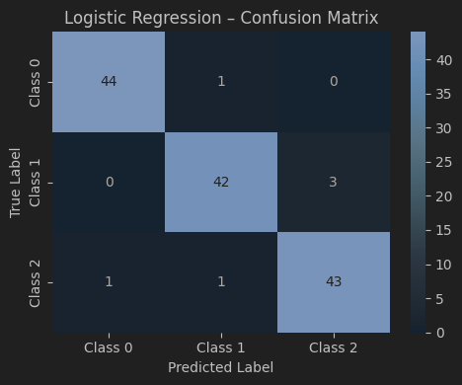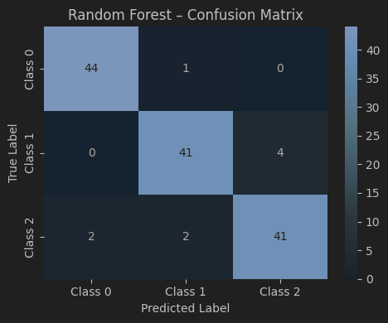

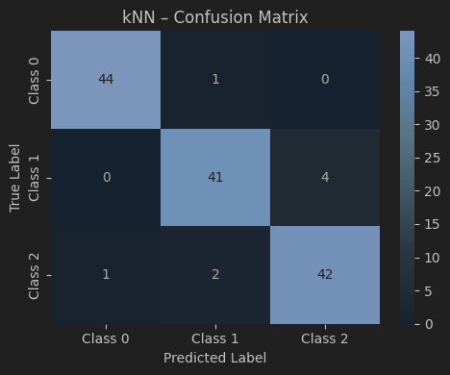

Overall Model Ranking
Based on the model evaluation and comparisons:
- Logistic Regression (Best overall)
- k-Nearest Neighbors (kNN).
- Random Forest.
Logistic Regression performs best overall, with the fewest misclassifications and consistently strong results across all classes. KNN also performs well but shows more confusion between Classes 1 and 2, while Random Forest makes the most errors, suggesting weaker generalization.

Classes 1 and 2 are the hardest to distinguish.
From the confusion matrices evaluations, it can be seen that most misclassifications occur between these two classes, indicating overlap in their feature distributions. This overlap makes it difficult for the models to clearly separate them, especially near decision boundaries, while Class 0 remains easier to identify due to better separation in the feature space.

Q2 - Part E: Decision Boundary Analysis

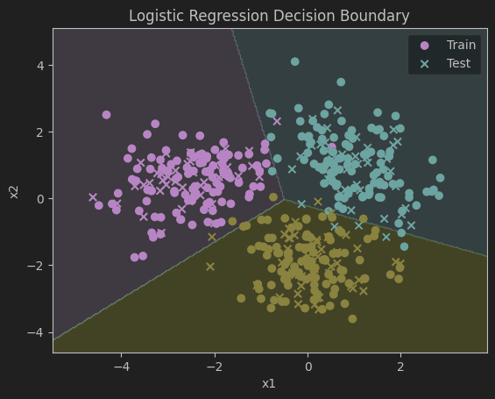
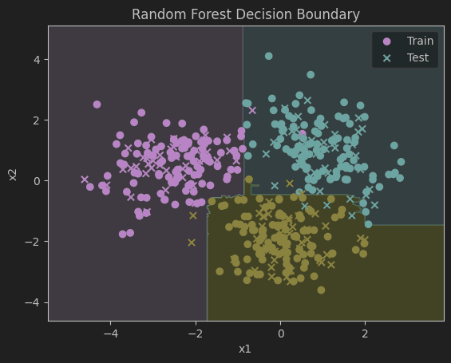
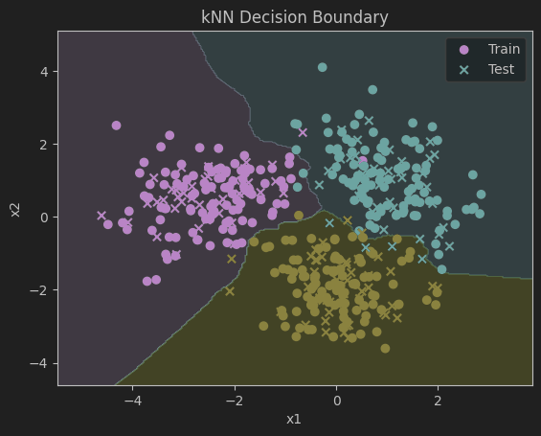

Boundary Smoothness
The Logistic Regression model produces smooth, linear decision boundaries that divide the feature space into broad regions, reflecting its linear nature. The kNN model shows highly irregular and jagged boundaries that closely follow the local structure of the data. In contrast, the Random Forest model creates piecewise, axis-aligned boundaries that are non-linear but more structured than those of kNN.

Overfitting vs Underfitting
Logistic Regression slightly underfits the data, as its linear boundaries cannot fully capture the curved separation between classes. kNN shows signs of overfitting, with complex boundaries that closely adapt to training points, especially near class overlaps. Random Forest strikes a better balance, capturing non-linear patterns while maintaining relatively stable boundaries.

Sensitivity to Noise and Class Overlap
kNN is the most sensitive to noise, as individual training points can significantly alter local decision regions. Logistic Regression is less sensitive to noise but struggles in overlapping regions where linear separation is insufficient. Random Forest is more robust to noise due to ensemble averaging, although some ambiguity remains in areas where classes overlap.

Q2 - Part F (1): Which classifier best matches the true data distribution, and why?

Logistic Regression best matches the true data distribution.
From the results, it has the fewest misclassifications overall, and its decision boundary plot shows clean, stable separations that align well with the roughly well-separated class structure in the dataset. Since the classes appear to be largely separable with fairly simple boundaries, a linear multiclass model fits the underlying pattern well without overreacting to noise.

Q2 - Part F (2)

a) Computational resources are limited
Logistic Regression
It trains quickly, has low memory and computational requirements, and prediction is fast, while still performing strongly on the dataset.

b) The dataset grows to 100,000 samples
Logistic Regression or Random Forest depending on the goal:
- Logistic Regression: scales very well from moderate to somewhat large datasets and stays fast to train and predict.
- Random Forest: can perform very well, but training time and memory usage increase significantly with more trees and more data.

Part F (3)

a) Where do their decision boundaries agree or disagree?
The best clustering algorithm in Q1 was K-Means, which creates straight-line boundaries based on distance to centroids. The best classifier from Q2, Logistic Regression also produces linear boundaries, so they agree on the overall partitioning of the space especially in regions where the clusters/classes are clearly separated. They may disagree near overlapping areas especially between Classes 1 and 2, because Logistic Regression uses class labels to place boundaries to reduce classification error, while K-Means only optimizes within-cluster compactness.

b) What does this say about supervised vs unsupervised learning?
This highlights the key difference: supervised learning uses class labels, so it can place boundaries that directly optimize class separation and reduce misclassification. Unsupervised learning has no access to labels, so it groups points based on structure e.g distance/density and its boundaries reflect cluster geometry rather than class correctness. When the data’s natural clusters align with class labels, the two approaches agree strongly; when they don’t or when there’s overlap, supervised models tend achieve better decision boundaries for prediction.

Q3 - Part A: Dataset Visualization and Relationship Analysis
Based on the plot with the overlaid linear fit, a linear model is not sufficient to capture the relationship between x and y. The linear model fails to capture the strong curvature present in the data and exhibits systematic deviations across the range of x.
Below is a visual justification of the plot
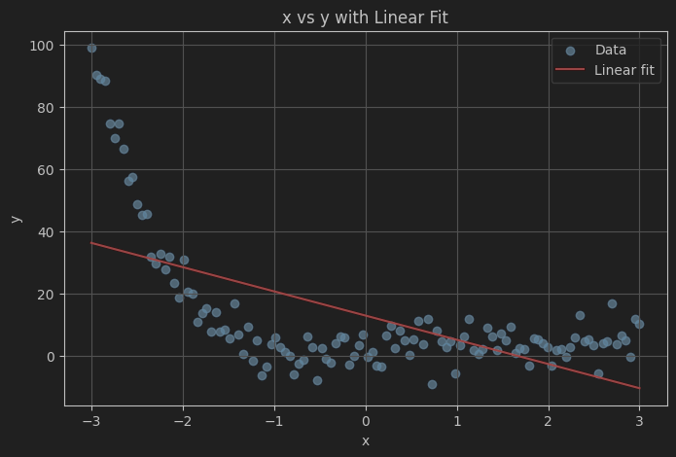

Q3 - Part A: Model Implementations

Model Implementation for Simple Linear Regression and Polynomial Regression with degree d= {2,3,4}
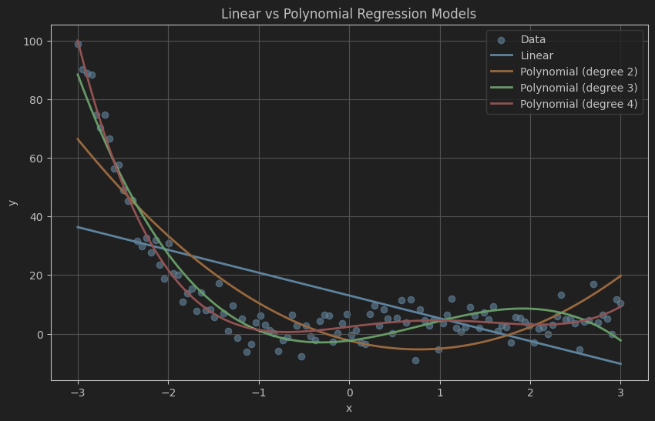

Q3 – Part B: Regression Equation for each Model

Equation for Simple Linear Regression
The linear regression model is based on the assumption of a straight-line relationship:
Such that; y^​ = β₀​+β₁​x
Where:
- β₀​ is the intercept
- β₁ is the slope (rate of change of y with respect to x)

Equation for Polynomial Regression where d = {2,3,4}
Polynomial Degree d | Equation | Note
d = 2 | y^​=β₀​+β₁​x+β_{2​}x² | - Introduces quadratic curvature  - Can model simple nonlinear relationships  - Still relatively low complexity
d = 3 | y^​=β₀​+β₁​x+β₂​x²+β₃​x³ | - Captures asymmetric curvature  - More flexible than degree 2  - Better suited for complex nonlinear patterns
d = 4 | y^​=β₀​+β₁​x+β₂​x²+β₃​x³+β₄​x | - Highly flexible model  - Can closely follow complex nonlinear trends  - Increased risk of overfitting, especially with noisy data

Q3 – Part C: Model Training and Evaluation
The table below shows the evaluation result for all the trained models
Model | MSE | RMSE
Linear Regression | 283.782 | 16.846
Polynomial (degree 2) | 117.024 | 10.818
Polynomial (degree 3) | 35.311 | 5.942
Polynomial (degree 4) | 19.358 | 4.400

Q3 – Part D: Model Comparison and Error Analysis

Compare performance across polynomial degrees
- At degree 2, both training and test errors are relatively high, indicating the model is too simple to fully capture the nonlinear relationship.
- Moving to degree 3, there is a large reduction in both errors, showing that the model fits the data much better.
- At degree 4, training error decreases slightly and test error also decreases, but the improvement is smaller compared to the jump from degree 2 to 3.

Model | MSE | RMSE
Polynomial degree 2 | 117.024 | 10.818
Polynomial degree 3 | 35.311 | 5.942
Polynomial degree 4 | 19.358 | 4.400

Identify the best-performing degree
From the evaluation, the best performing Polynomial Degree will be Degree 3. Because it achieves the lowest MSE/RMSE and captures the nonlinear trend without fitting noise.

Plot training vs test error vs polynomial degree (MSE and RMSE)
A polynomial degree 3 provides a strong balance between model complexity and generalization, making it an appropriate choice.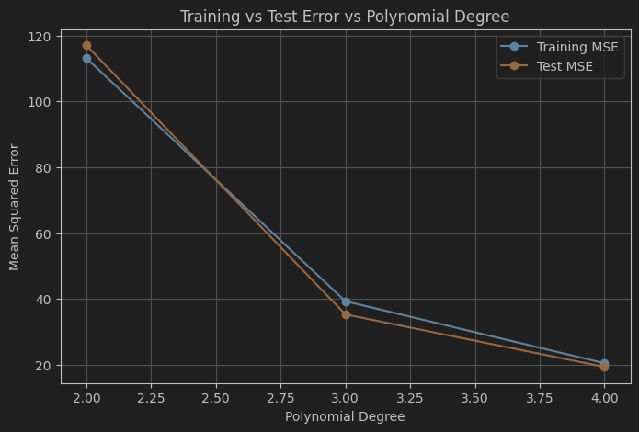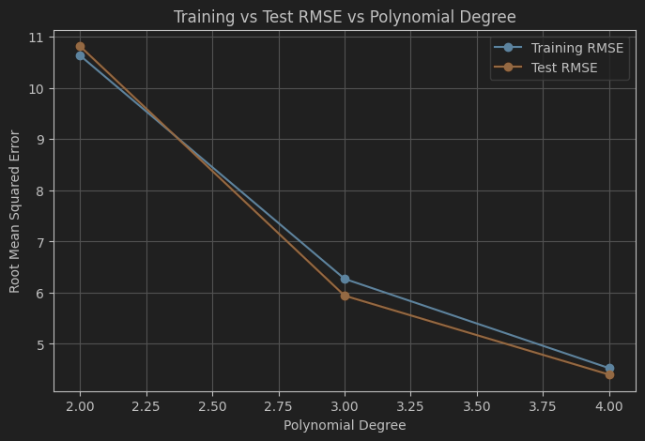

Q3 – Part E: Plot Prediction

Plot: Linear Regression Predictions
The linear regression predictions form a straight line that does not follow the curved nature of the dataset.
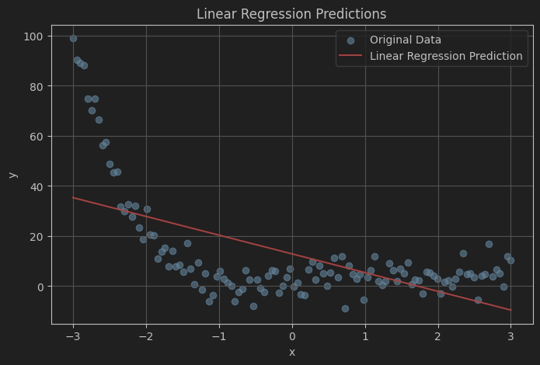

Plot: Best Polynomial Model Predictions (Degree 3)
The degree-3 polynomial model produces a smooth curve that closely follows the nonlinear trend of the dataset while ignoring random noise. This indicates a good balance between model flexibility and generalization, confirming it as the best-performing model.
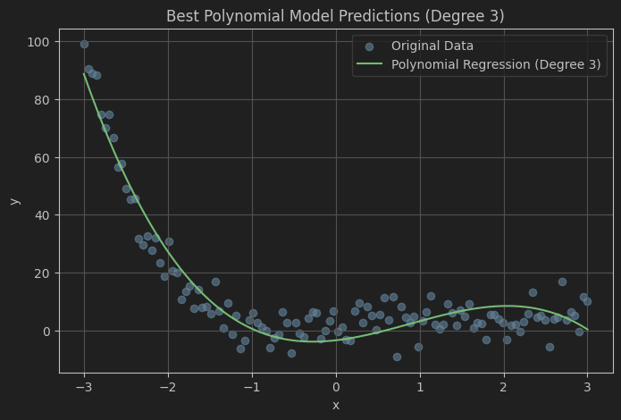

Plot: Overlay Predictions on the Original Data
The overlay plot shows that linear regression fails to capture the nonlinear structure of the dataset, whereas the best polynomial model accurately follows the underlying trend
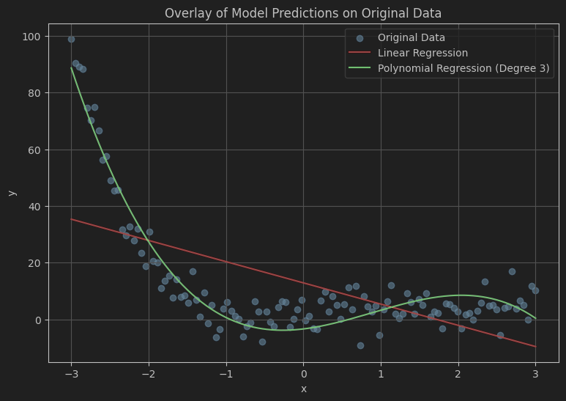

Q3 – Part F: Explanation

Why does linear regression fail on this dataset?
Linear regression fails because it assumes a straight-line relationship between the input x and the output y. In the dataset, the relationship between x and y is nonlinear, with a curved pattern and varying rates of change. As a result, a linear model cannot capture the true structure of the data and produces systematic errors, leading to underfitting and high prediction error.

Why does increasing polynomial degree beyond a point hurt generalization?
As the polynomial degree increases, the model becomes more flexible and starts fitting not only the underlying trend but also the noise in the training data. This causes the model to overfit, resulting in very low training error but worse performance on unseen test data. Consequently, generalization suffers because the model learns patterns that do not represent the true data-generating process.

